Culture | Back Story

幕后故事

（英文部分选自经济学人202200625期文化版块）

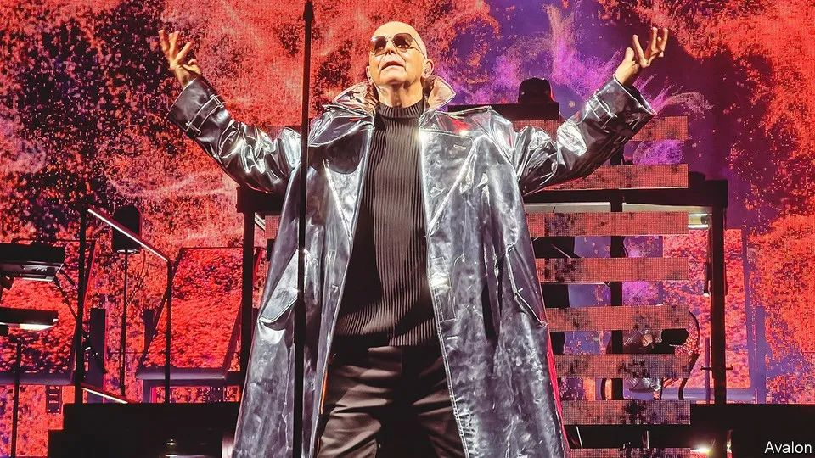

Pet Shop Boys achieved a kind of alchemy that only music can

宠物店男孩拥有一种唯有音乐可以获得的魔力

Their hits have endured because they **transmute** sadness **into** joy

热单经久不衰的秘密在于转悲为喜

When “It’s a sin” was released in 1987, gay marriage was barely a dream. Margaret Thatcher’s government would soon pass a law banning the “promotion of homosexuality” in classrooms. Neil Tennant, Pet Shop Boys’ singer and lyricist, **drew on** his spell at a Catholic school in Newcastle, characteristically using language at once limpid and flexible, so that the “sin” seems to cover all manner of impulses. In a video directed by Derek Jarman, Mr Tennant was tormented by inquisitors as he made his pulsating confession:

When I **look back upon** my life

It’s always with **a sense of shame**

I’ve always been the one to blame

1987年，单曲《这是罪》发布时，同性婚姻几乎是痴人说梦。要不了多久，玛格丽特·撒切尔政府将颁布一项法律，禁止在课堂上“宣扬同性恋”。尼尔·坦南特（Neil Tennant）是宠物店男孩的主唱兼词作者，得益于在纽卡斯尔的一所天主教学校里的经历，形成了标志性的清晰易懂又灵活多变的文字风格，因此“罪”这个词看起来涵盖了种种欲望。在德里克·贾曼（Derek Jarman）导演的一段视频中，坦南特遭受审判者的折磨时，他跟着节奏大声忏悔:

当我回顾一生

羞耻感挥之不去

一直都是我的错

Times have changed. Mr Tennant (pictured) **came out** in 1994; recently **his song lent its title to atv drama** about the aids crisis of the 1980s. He and Chris Lowe, the keyboardist and other half of Pet Shop Boys, are in their 60s. Yet on June 26th they will headline the Glastonbury festival, **midway into** a greatest-hits tour bound from Europe to North America in the autumn. Their **staying power** is down to more than stamina or fans’ nostalgia: their best music still **pulls off** an emotional alchemy that few bands—and no other art form—can match.

如今时代变了。坦南特（如图）于1994年出柜; 近来，一部讲述20世纪80年代艾滋病危机的电视剧借用了他的歌名。他和组合的另一位成员——键盘手克里斯·洛（Chris Lowe），如今都已经60多岁。不过在6月26日，他们将成为格拉斯顿伯里音乐节的主角，这也是他们今年秋季精选集巡演（从欧洲到北美）中途的一次演出。他们的作品经久不衰，原因不仅在于他们的坚持或粉丝的怀旧情绪：他们最好的音乐作品至今仍然具有一种情感魔力，没有几支乐队（也没有其他的艺术形式）能够与之匹敌。

The pair met in a synthesiser shop on the King’s Road in 1981, both northerners in London (Mr Lowe is from Blackpool) and keen on electronic music. Some of their songs are hymns to the city, its promise and loneliness, exhilaration and vertigo. From the black opening—“Sometimes, you’re better off dead”—“West End Girls”, a transatlantic number one in 1986, mixes anomie with the frisson of cross-class desire, the glitz and grind of “a West End town in a dead-end world”.

组合二人于1981年在伦敦国王路的一家合成器商店相识，他们都来自伦敦北部（克里斯·洛来自布莱克浦）并热衷电子乐。他们的部分歌曲歌颂伦敦，这座给人希望，也让人倍感孤独，既令人兴奋，也令人眩晕的城市。“有时候，你生不如死”——单曲《西区女孩》（West End Girls）的开头便如同黑色电影。1986年这首歌在英美两国排行第一，其中既讲述了道德缺失的故事，也融入了跨阶级欲望带来的兴奋，以及“封闭世界里的西区小镇”的浮华与苦闷。

That song was influenced by the chattering voices in “The Waste Land”. Russian history is a recurring motif in Mr Tennant’s lyrics; some are sly critiques of Thatcherism. Since their “imperial phase” in the late 1980s, the duo have confirmed their reputation for “intellectronica” with a pop oratorio about the gay codebreaker Alan Turing and a soundtrack for Sergei Eisenstein’s “Battleship Potemkin”.

《西区女孩》（West End Girls）的创作灵感源于艾略特（T. S. Eliot）《荒原》（The Waste Land）里喋喋不休的闲谈。俄罗斯历史是坦南特先生（Mr Tennant）歌词中反复提及的主题；一些歌词也隐晦地批判了撒切尔主义。双人组合自其20世纪80年代末的“黄金时代”以来，创作了一部关于同性恋密码破译天才艾伦·图灵（Alan Turing ）的流行清唱剧，外加一首为谢尔盖· 爱森斯坦（Sergei Eisenstein）执导的《战舰波将金号》（Battleship Potemkin）创作的电影配乐，令他们电子流行乐（intellectronica）的盛誉实至名归。

For all the bookishness, though, the band’s appeal lies partly in a kind of sublime simplicity: expressing sadness and longing in plain yet supple words that are poignant even when they also seem ironic. “What Have I Done to Deserve This” mourns a failed relationship, “Rent” the sense of being trapped in one (“Look at my hopes, look at my dreams…”). “Suburbia” laments the claustrophobia of the suburbs, “Being Boring” the way the lives of friends diverge, and some end prematurely: “All the people I was kissing/Some are here and some are missing.” That track commemorated a friend who died of aids; on the current tour Mr Tennant dedicates it to the victims of covid-19.

然而，尽管有些书生气，宠物店男孩对听众的魔力一定程度上在于大道至简：平实而灵活的语言表达出悲伤和渴望，即便有时看上去颇具讽刺性。《我做了什么以致如此》（What Have I Done to Deserve This）怀念一段失败的恋情；《租金》（Rent）表达了受困于恋情中的感觉（看看我的希望，看看我的梦想……）；《郊区》（Suburbia）哀叹郊区生活的幽闭之感；《无聊》（Being Boring）唱出朋友们生活方式的不同，一些朋友英年早逝：“过去我曾亲吻过的每一位朋友／一些人还伴我左右，一些人已与我天人永隔”。这首歌纪念一位死于艾滋病的朋友；如今，在巡回演唱会上，坦南特先生将其献唱给新冠疫情的受害者。

The other part of Pet Shop Boys’ genius is to set these **feelings of heartache** to tunes that urge you to **wave your arms**, **stamp your feet** and **chant the chorus**. Their sound brought together the tempo of the “hi-nrg” dance music that had developed in America with influences from David Bowie and Kraftwerk to film scores and rap, **combining** them **into** a dramatic brand of electropop. **It counterpoints the melancholy of the lyrics with infectious beats, arresting key changes, swooning refrains and operatic climaxes.**

宠物店男孩另一个天才之处在于，他们将痛彻心扉的感觉唱出别样的曲调：让人不自觉地挥舞双臂、踏着拍子、齐声合唱。他们将源于美国的“高能量舞曲”（hi-nrg）节奏和大卫·鲍伊（David Bowie）及发电站乐队（Kraftwerk）的风格融合在一起，以此创作电影配乐和说唱，形成了一种戏剧性的电子流行乐。他们的歌曲中，感染力十足的节拍、扣人心弦的音调起伏、令人心醉神迷的副歌和戏剧性高潮都与忧郁的歌词形成鲜明对比。

So when Mr Tennant sings about running with the dogs in suburbia, you want to run with them. In “Left to My Own Devices”, a rousing riff on isolation, you wouldn’t mind being in the head of the “lonely boy, no strength, no joy” who hears “Che Guevara and Debussy to a disco beat”.

因此当坦南特先生唱到在郊区和狗狗一起奔跑的情景，你会渴望自己也和他们一同奔跑起来。《我行我素（Left to My Own Devices）》这首歌就孤独意象采用了动感的重复乐段，你不会介意钻进那个“无精打采、了无生趣的孤独男孩”脑子里，听他脑海里“切·格瓦拉（Che Guevara）和德彪西（Debussy）打着迪斯科节拍”。

In the new show, the act’s trademark lighting and effects illuminate an otherwise limited spectacle—Mr Lowe standing as impassively as ever at his keyboard as Mr Tennant potters about the stage. For “It’s a Sin”, flames and bursts of crimson swirl behind them. The throbbing chords and breathless crescendos turn shame into defiance, repression into joy.

For everything I long to do

No matter when or where or who

Has one thing in common, too:

It’s a…It’s a…It’s a…It’s a sin.

最新的演出里，克里斯·洛一如既往面无表情地站在键盘前，而尼尔·坦南特在舞台上闲庭信步，标志性的舞台灯光和舞美效果让原本平淡的场面壮丽起来。《这是罪》响起，一圈深红色火焰将两人围在中间、骤然炸裂，随着和弦的震动与令人屏息的持续渐强，歌曲表达的羞愧变成了反抗、压迫变成了喜悦。

我渴望的所有事物

无论时间 地点 或人物

都有一个共通之处

那 那 那就是都是罪

**Classic songs are a time machine. These hits teleport Pet Shop Boys’ older listeners to their youth, a thrill even if those years were hard. They capture the bygone mood of a gritty age. More than that, they let you smile at sorrow, at once echoing your woes and making you feel better. Doing either is an artistic achievement; doing both together is a feat that only words and music can perform, and only rarely. It will never get old.**

经典曲目是一座时光机，这些风靡一时的歌曲把宠物店男孩的老歌迷们送回了青春时节，即便那时艰难坎坷，却令人想到就心颤。宠物店男孩不仅捕捉住了往昔峥嵘里的坚韧不拔，他们还能让你笑对悲伤，既能共情你的苦痛，又能缓解你的难过。能做到这两点中的任意一点就是一项艺术成就，能同时做到这两点则对文字表达和音乐旋律都要求颇高，实属凤毛麟角。经典永不过时。